Connector Configuration
Prerequisite: Need a user ID for RFC connection in PLUG-IN system (S4HANA/ECC). User ID should be SYSTEM or COMMUNICATION type and should be assigned with necessary (RFC) authorizations. Auth Objects starting with S_RFC* would give access to RFC related authorizations.
Path for 1st 3 steps of Connector Configuration:
SPRO ---- > GRC ----- > Common Component Settings ----- > Integration Framework
- Create Connector (SM59)
Set up of RFC between Plug in system and GRC systems
GRC system – FR1 800
ECC (Plug in system) – FE1 800
RFC Connection:
FR1 800 (GRC) -------- > FE1 800 (ECC) = FE1CLNT800 (BHPCLNT800) Ex,, 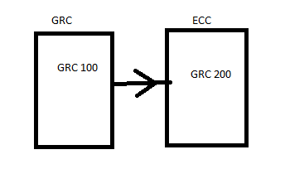 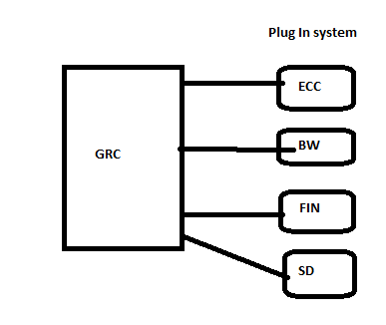
GRC 200 ----------VAS 800: GSCLNT800
Note: Ensure that RFC Connection name is defined in CAPITAL Letters.

Why ECC/S4HANA is connected to GRC?
ECC - ED1, EQ1, EP1
BW - BD1, BQ1, BP1
GRC - GD1, GQ1, GP1

Cannot be transported:
GD1 100---- > ED1 100 Connector: ED1CLNT100
GQ1 100 ------> EQ1 200 Connector: EQ1CLNT200
GP1 100 ---- > EP1 100 Connector: EP1CLNT100

Transportable data:
GD1 100---- > ED1 100 Connector: ECC100
GQ1 100 -----> EQ1 100 Connector: ECC100
GP1 100 ---- > EP1 100 Connector: ECC100

- Maintain Connectors and Connection Types
- Define Connectors: Source Connector & Logical Port should be same as Target connector
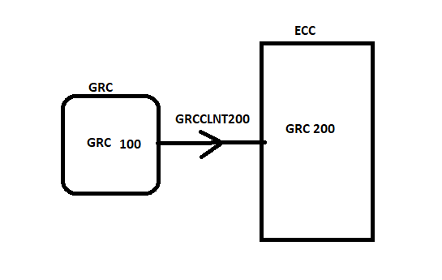
- A.1) Define Subsequent Connector – This is required for JAVA systems only. Not required for ABAP system. Subsequent Connector is created by BASIS Team.

- Define Connector Groups – Create a Group
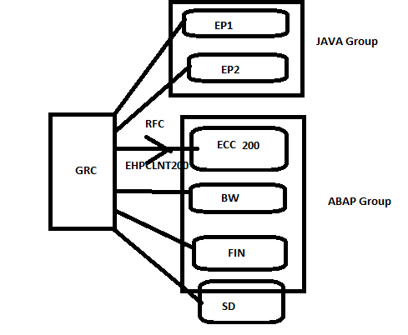
2. B.1) Assign Connector Groups to Group Types: Define your Connector group status as Logical Group for AC
2. B.2) Assign Connectors to Connector Groups – Put the connector which you have created in Step 1 under this Connector Group just created.
- Maintain Connection Settings
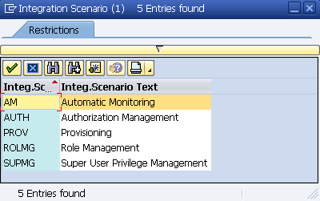

AM: Process Control

Access Control related Integration Scenarios
AUTH: Related to BRM, ARA
PROV: Related to ARM
ROLMG: Related to BRM
SUPMG: Related to EAM
Path: SPR0 ----- > GRC ---- > Access Control
- Maintain Connector Settings ----- > Define Application Type, Environment and PSS. PSS stands for Password Self Service.
- Maintain Mapping for Actions and Connector Groups
- Maintain Connector Group Status ---- > Enter your connector group name and make it active.
- Assign default connector to connector group
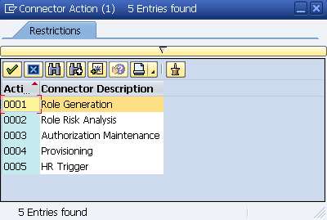

- Under one connector group, only 1 system can act as Default Connector for one Action.
- All systems under connector group, should be mapped with all actions, but only one system can act as Default Connector

